**WEEK -**

**Aim**: To Implement Neo4J Graph Database.

**Screenshots of execution:**

1) Create command

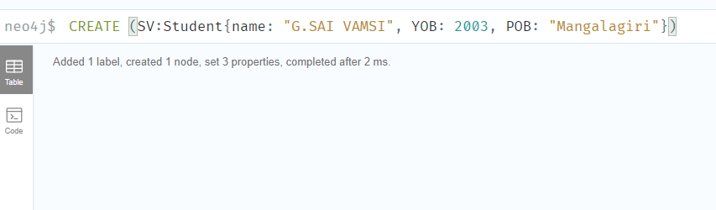

2) Search for some node using match and then creating relations between two nodes (edges)

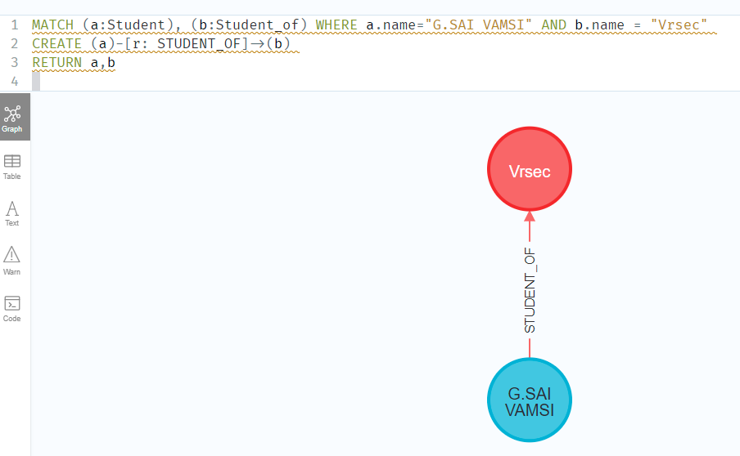

3) MATCH(n) RETURN(n) -> Return to display output graph

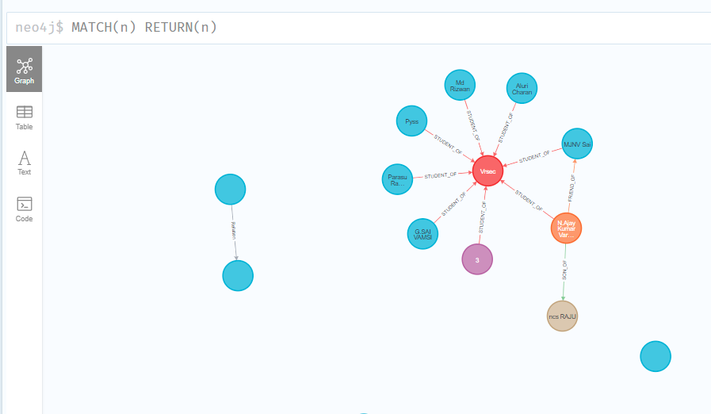

🡪Creating more edges and establishing Relations between them.

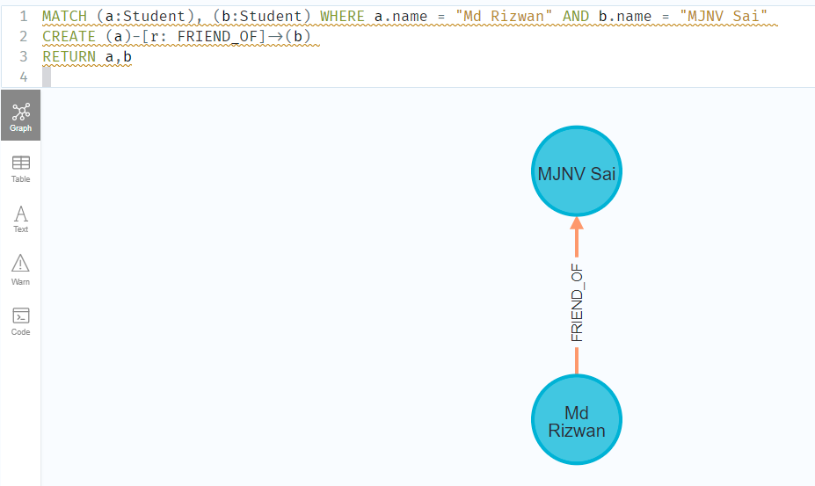

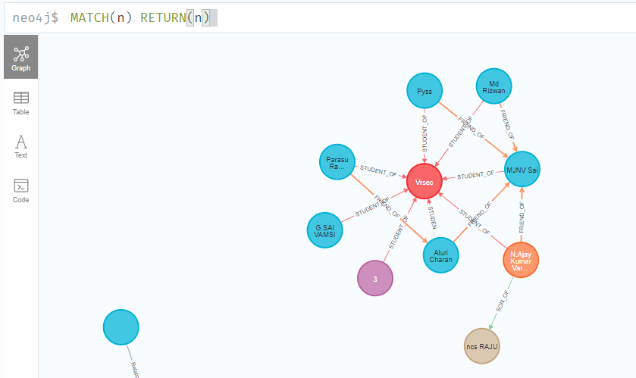

**Final Graph Obtained:**

